**1. Prepare a short note on the following hardware components.**

a. Motherboard

b. Internal storage devices

i. RAM- different types

ii. ROM

iii. Hard Disk

c. SMPS

d. daughter cards

e. Bus slots

f. Interfacing ports

**a) Motherboard:**

A motherboard is the main printed circuit board ([PCB](https://www.techtarget.com/whatis/definition/printed-circuit-board-PCB)) in a computer. The motherboard is a computer's central communications backbone connectivity point, through which all components and external peripherals connect.Motherboards can be found in virtually all computers, especially desktop and laptop PCs. The components that connect through them include chipsets, central processing units ([CPU](https://www.techtarget.com/whatis/definition/processor)) and memory. The external peripherals include Wi-Fi, Ethernet and graphics cards with the graphics processing unit, or GPU.

Motherboard manufacturers include Acer, ASRock, Asus, Gigabyte Technology, Intel and Micro-Star International.

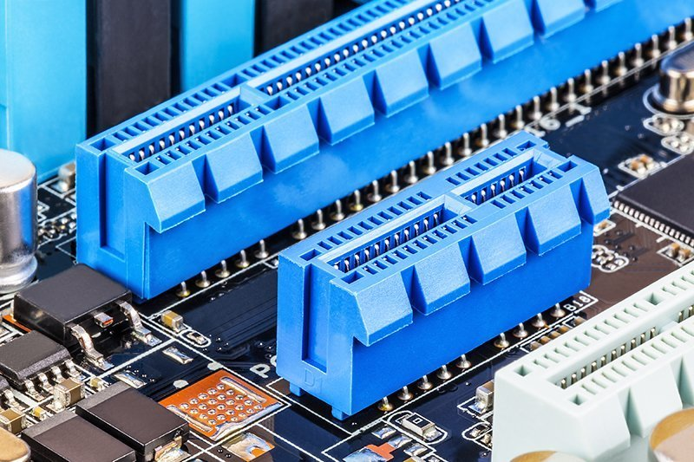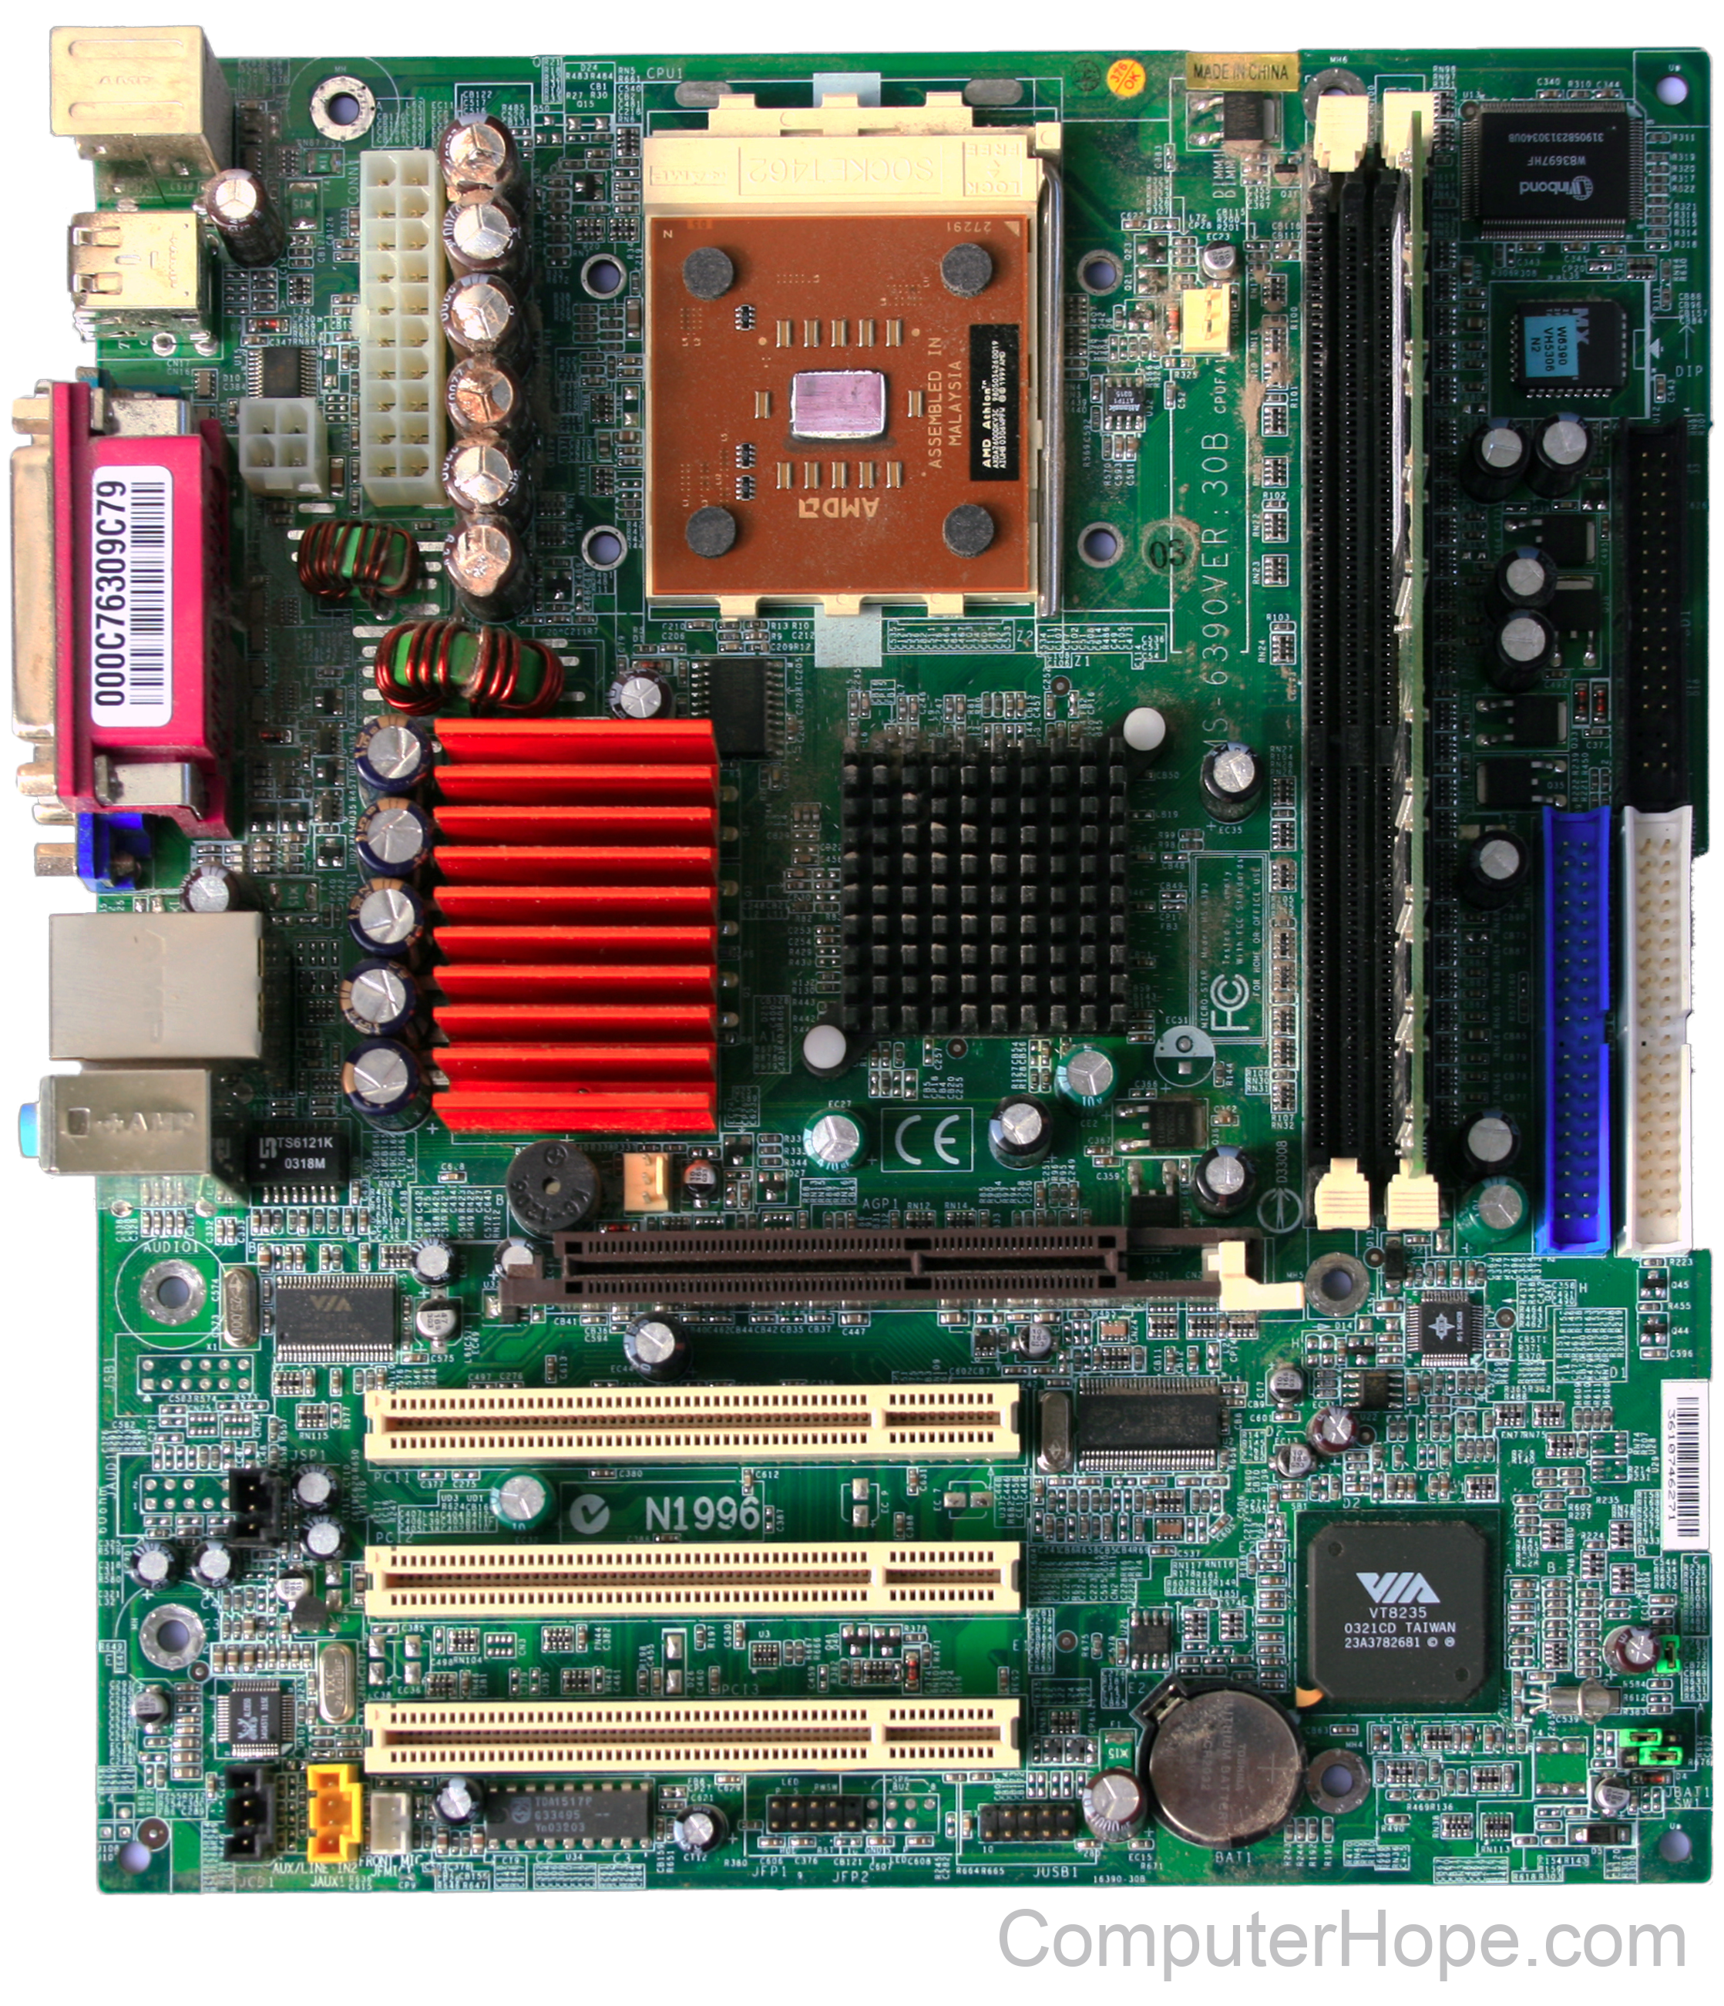

**b)Internal storage devices**

A storage device comes in a variety of shapes and sizes; for example, a computer has numerous file systems such as a hard drive, RAM, and cache. These have also optical disc drives and USB drives that may be linked outside. There are two sorts of storage systems that store data: main and secondary.

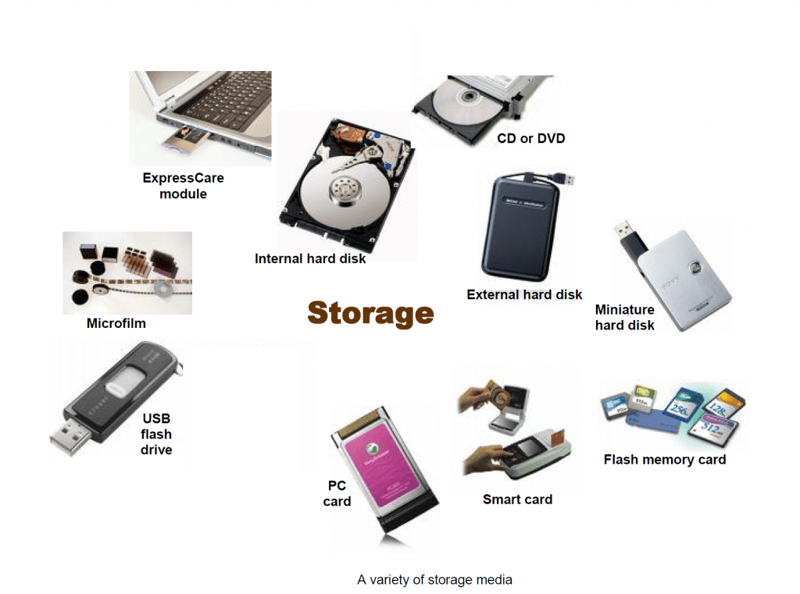

**i) RAM- different types**

RAM(Random Access Memory) is a part of the computer’s Main Memory which is directly accessible by the[CPU](https://www.geeksforgeeks.org/central-processing-unit-cpu/). RAM is used to Read and Write data into it which is accessed by the CPU randomly. RAM is volatile in nature, which means if the power goes off, the stored information is lost. RAM is used to store the data that is currently processed by the CPU. Most of the programs and data that are modifiable are stored in RAM.

Integrated RAM chips are available in two forms:

* [SRAM (Static RAM)](https://www.geeksforgeeks.org/difference-between-sram-and-dram/)
* [DRAM (Dynamic RAM)](https://www.geeksforgeeks.org/difference-between-sram-and-dram/)

[**SRAM (Static RAM)**](https://www.geeksforgeeks.org/difference-between-sram-and-dram/):

The [SRAM](https://www.geeksforgeeks.org/sram-full-form/)memories consist of circuits capable of retaining the stored information as long as the power is applied. That means this type of memory requires constant power. SRAM memories are used to build Cache Memory.

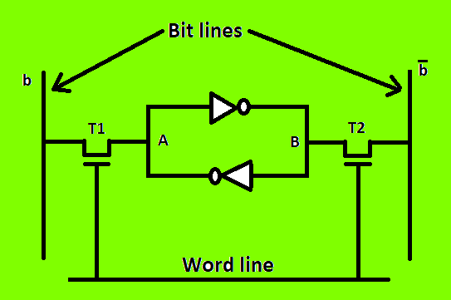

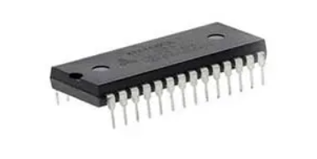

**DRAM (Dynamic RAM):**

DRAM stores the binary information in the form of electric charges applied to capacitors. The stored information on the capacitors tends to lose over a period of time and thus the capacitors must be periodically recharged to retain their usage. DRAM requires refresh time. The main memory is generally made up of DRAM chips.

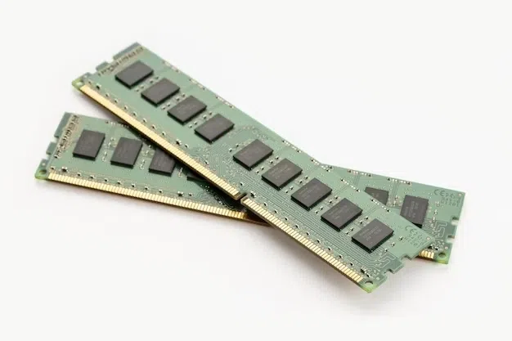

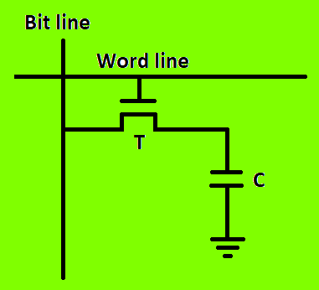

**ii. ROM**

ROM, which stands for read only memory, is a memory device or storage medium that stores information permanently. It is also the primary memory unit of a computer along with the random access memory (RAM). It is called read only memory as we can only read the programs and data stored on it but cannot write on it. It is restricted to reading words that are permanently stored within the unit.

The manufacturer of ROM fills the programs into the ROM at the time of manufacturing the ROM. After this, the content of the ROM can't be altered, which means you can't reprogram, rewrite, or erase its content later. However, there are some types of ROM where you can modify the data.

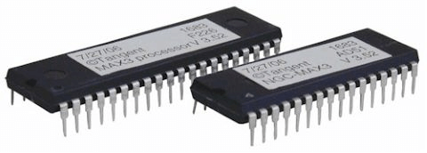

## Features of ROM:

* **Non-Volatile Memory:** ROM is a non-volatile memory type; thus, it keeps its data even when the power is switched off. This makes it suitable for storing permanent instructions and data since it guarantees that the recorded information will remain intact and may be accessed whenever necessary.
* **Read-Only Nature:** Reading-only memory, or ROM, as its name implies, prevents data from being readily modified or wiped. This characteristic provides stability and prevents accidental alterations, ensuring the integrity and reliability of the stored information.
* **Permanent Storage:** ROM offers permanent storage of data and instructions. Once the data is programmed into ROM during manufacturing, it remains fixed and cannot be changed without physically replacing the ROM chip. This permanence guarantees the consistency and stability of the stored information.
* **Firmware Storage:** ROM is commonly used for storing firmware containing essential instructions for operating electronic devices. ROM's non-volatile and read-only nature ensures that the firmware remains unchanged, providing reliable and consistent functionality to the device.
* **Booting and Initialization:** ROM plays a crucial role in electronic systems' booting and initialization processes. The firmware stored in ROM contains the initial instructions required to start the system, load the operating system, and initiate the hardware components. This ensures a smooth and controlled startup sequence for the device.
* **PROM (Programmable Read-Only Memory):**PROM chips can be written to once but not erased or rewritten after that. They are typically used to store small amounts of code or data such as basic input/output system (BIOS) settings.
* **EPROM (Erasable Programmable Read-Only Memory):**EPROM chips can be rewritten multiple times using ultraviolet light exposure through an eraser window on the chip package. This type of chip is often used to store BIOS settings in PC motherboards or game consoles.
* **EEPROM (Electrically Erasable Programmable Read-Only Memory):** EEPROM chips can also be rewritten multiple times but with an electric charge rather than ultraviolet light exposure. This type of chip is often found in mobile phones and flash drives where frequent updates may be necessary.
* **Flash Memory:**Flash memory contains both program code and user data and can be written to multiple times without needing to be erased first like PROM or EPROM chips do. Flash memory is commonly found in USB drives and digital cameras because it does not require any special tools for writing or erasing its contents.

**iii. Hard Disk**

A hardisk  is also known as a hard drive or fixed disk. It is said to be rigid magnetic disc that stores data. It is located within a drive unit. Hard disk is a non-volatile storage device that contains platters and magnetic disks rotating at high speeds. Non-volatile means the data retains when the computer shuts down.It is installed internally in our computer systems. Hard disk is located within a drive unit on the computer's motherboard and comprises one or more platters packed in an air-sealed casing.

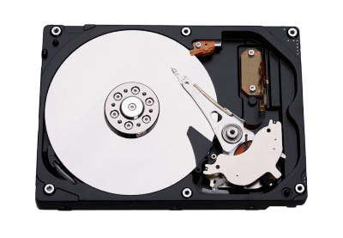

Its main components include a read/write actuator arm, head actuator, read/write head, spindle, and platter. A circuit board (also called as the interface board or disk controller) is present on the back of a hard drive. It lets the hard drive to communicate with the computer.

**c) SMPS: Switched-Mode Power Supply/ Switching Mode Power Supply**

SMPS stands for Switched-Mode Power Supply. It is an electronic power supply that uses a switching regulator to convert electrical power efficiently. It is also known as Switching Mode Power Supply. It is power supply unit (PSU) generally used in computers to convert the voltage into the computer acceptable range.This device has the power handling electronic components that converts electrical power efficiently. Switched Mode Power Supply uses a great power conversion technique to reduce overall power loss.

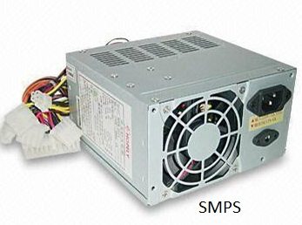

**d) Daughter cards**

A daughter card (otherwise known as a controller card) is a variation of circuit boards. It gets added to the motherboard on a device to improve the device's functionality.A daughtercard or daughterboard is a type of circuit board that gets added to an existing one. Its name is appropriate for its use, since it is connected to a “motherboard” or “main board.” The motherboard is the primary circuit board for a device. It is usually in the device as it is shipped from the factory. A daughtercard may be added later.

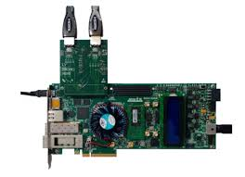

**e) Bus slots**

Alternatively known as a bus slot or expansion port, an expansion slot is a connection or port inside a computer on the motherboard or riser card. It provides an installation point for a hardware expansion card to be connected. For example, if you wanted to install a new video card in the computer, you'd purchase a video expansion card and install that card into the compatible expansion slot.

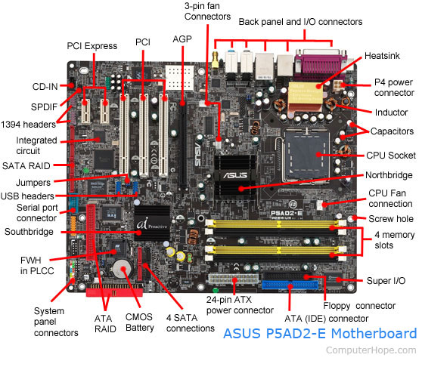

**f ) Interfacing ports**

A computer is a device that transforms data into meaningful information. It processes the input according to the set of instructions provided to it by the user and gives the desired output. As we know that we can connect multiple external devices with the computer system. Now, these devices are connected with the computer using Ports. The ports are the physical docking points present in the computer through which the external devices are connected using cables. Or in other words, a port is an interface between the motherboard and an external device of the computer. There are different types of ports available:

* Serial port
* Parallel port
* USB port
* 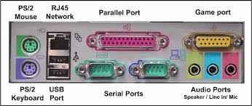PS/2 port
* VGA port
* Modem port
* FireWire Port
* Sockets
* Infrared Port
* Game Port
* Digital Video Interface(DVI) Port
* Ethernet Port

**2. Write the specification for a desktop computer.**

|  |  |
| --- | --- |
| Component | Specification |
| Processor: | 11th, 12th or 13th Gen Intel Core i5, i7 or i9 Processor, Apple Silicon M1, M1 Pro, M1 Max, M1 Ultra or M2 Processor (CPU) |
| Operating System: | Microsoft Windows 10 or Windows 11 Home, Pro, Enterprise or Education version or macOS 11.X “Big Sur” or macOS 12.X “Monterey.” |
| Office Suite: | Microsoft Office 365 for Windows or Macintosh. Microsoft Office 365 is available for no-cost download for all enrolled students. See the UDel Office 365 for Education services page for details. |
| Memory (RAM): | 8-16 GB of RAM |
| Storage: | 240 GB solid state drive, or larger. |
| Video/Graphics: | Integrated or discrete graphics processor capable of 1440 X 900 resolution, or better (1920 X 1080 or 1200 ideal). |
| Monitor: | for notebook: 13″ – 17″ display for desktop: 24″ – 27″ widescreen flat-panel display |
| Mouse: | Built-in or external trackpad, wireless and/or USB, 2-button, optical mouse |
| Sound: | Built-in audio or soundcard, and speakers |
| Headphones: | Headphones or earbuds, with built-in microphone |
| Webcam: | Either external USB device or built-in |
| Network: | 802.11ac (or better) Wi-Fi capability. |
| Warranty: | 3 year on-site (better) or depot warranty, accidental damage service highly recommended. |
| Backup device/scheme: | External USB or Thunderbolt drive with Time Machine (Mac) or Windows backup software and/or cloud backup service/subscription. |
| Recommended Accessories: Printer (wireless or USB connected w/USB cable), USB flash memory drive (“USB key” or “thumb drive”), surge suppressor, carrying case for notebooks. Mac users wishing to connect their notebook computers to classroom projectors for presentation purposes should purchase VGA or HDMI adapters appropriate for their specific Macintosh computer model (MacBook Air, MacBook Pro, etc.) OR USB-C hub for multiple connections. Optional: Optical drive (recordable DVD or Blu-Ray drive). | |

**3. Write the specification for a server computer.**

**Hardware Requirements**

STA requires a dedicated server with the minimum configuration listed

**TABLE 2‑8**STA Minimum Hardware Requirements

|  |  |
| --- | --- |
| **Hardware** | **Configuration** |
| Processor | Intel Xeon 5600 Series or equal AMD CPU |
| Memory | 16 GB RAM |
| Operating System Disk | Dual HDD drives, 1 TB each |
| Connection | Gigabit Ethernet |
| Platform | All disk storage residing on single platform |

### **Operating System Requirements**

The Linux operating systems supported for STA are listed in TABLE 2‑9.

**TABLE 2‑9**Operating System Versions Supported for STA

|  |  |
| --- | --- |
| **Operating System** | **Supported Versions** |
| Oracle Enterprise Linux (OEL), 64-bit (Oracle kernel) | Release 5 Update 5 (5u5) (minimum) |
| Red Hat Enterprise Linux (RHEL), 64-bit (Red Hat kernel) | Release 5 Update 5 (5u5) (minimum) |

### **Server IP Address Requirement**

The server on which STA is installed must have a static IP address assigned. Dynamic addressing (DHCP) is not supported.

### **Server Subnet Recommendation**

Oracle recommends that you place the server on which STA is installed on the same subnet as the library to improve SNMP UDP reliability.

If you want to configure STA to support dual TCP/IP on the library using two distinct subnets, the network must be configured to allow the delivery of SNMP packets on either subnet between the library and STA. Consult your network administrator and Oracle support representative for more information.

### **Firewall Port Configuration**

For STA to retrieve and receive data, configure firewalls and routers to open the following ports in TABLE 2‑10.

**TABLE 2‑10**Ports Used by STA

|  |  |
| --- | --- |
| **Port** | **Purpose** |
| 22 | Secure Shell (SSH) |
| 80, 8080 | Unsecure HTTP communication between STA and browser |
| 443 | Secure HTTPS (over SSL/TLS) communication between STA and browser |
| 161 | Simple Network Management Protocol (SNMP) |
| 162 | Simple Network Management Protocol Trap (SNMPTRAP) |
| 7001 | WebLogic Admin Console login, HTTP |
| 7002 | WebLogic Admin Console login, HTTPS |
| 7021 | STA GUI login, HTTP |
| 7022 | STA GUI login, HTTPS |

### **User Interface Requirements**

Refer to the “Getting Started” chapter of the STA User Interface Guide.

### **Authentication Requirements**

The following types of authentication can be used by STA:

|  |  |  |  |
| --- | --- | --- | --- |
| • | | Local WebLogic users | |
| • | | | Open LDAP users |
| • | RACF users (if using RACF for authentication) | | |

**4. Write short note on the following.**

a. Operating System

b. Linux

c. Ubuntu

d. Virtual Machine

e. Kernel

f. Shell

g. Terminal

h. Bash

i. Shell scripting

**a. Operating System:**

An operating system (OS) is the program that, after being initially loaded into the computer by a boot program, manages all of the other application programs in a computer. The application programs make use of the operating system by making requests for services through a defined application program interface (API).

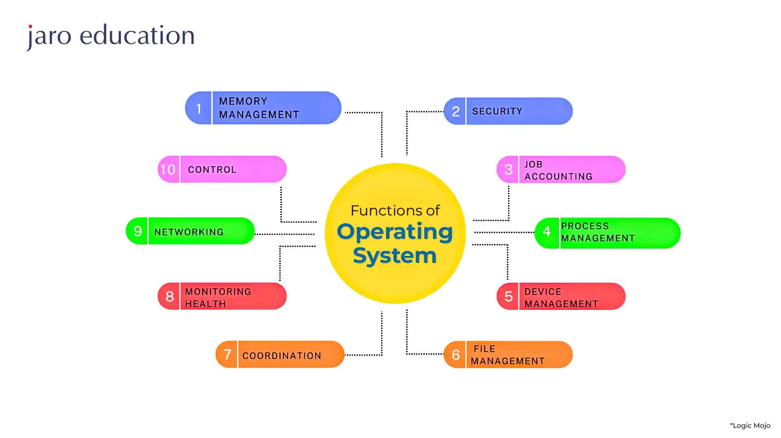

**b. Linux**

Linux® is an open source operating system (OS). An operating system is the software that directly manages a system's hardware and resources, like CPU, memory, and storage. The OS sits between applications and hardware and makes the connections between all of your software and the physical resources that do the work.

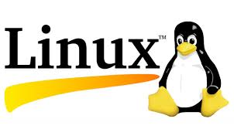

The Linux operating system comprises several different pieces:

1. **Bootloader –** The software that manages the boot process of your computer. For most users, this will simply be a splash screen that pops up and eventually goes away to boot into the operating system.
2. **Kernel –** This is the one piece of the whole that is actually called ‘Linux’. The kernel is the core of the system and manages the CPU, memory, and peripheral devices. The kernel is the lowest level of the OS.
3. **Init system –** This is a sub-system that bootstraps the user space and is charged with controlling daemons. One of the most widely used init systems is systemd, which also happens to be one of the most controversial. It is the init system that manages the boot process, once the initial booting is handed over from the bootloader (i.e., GRUB or GRand Unified Bootloader).
4. **Daemons –** These are background services (printing, sound, scheduling, etc.) that either start up during boot or after you log into the desktop.
5. **Graphical server –** This is the sub-system that displays the graphics on your monitor. It is commonly referred to as the X server or just X.
6. **Desktop environment –** This is the piece that the users actually interact with. There are many desktop environments to choose from (GNOME, Cinnamon, Mate, Pantheon, Enlightenment, KDE, Xfce, etc.). Each desktop environment includes built-in applications (such as file managers, configuration tools, web browsers, and games).
7. **Applications –** Desktop environments do not offer the full array of apps. Just like Windows and macOS, Linux offers thousands upon thousands of high-quality software titles that can be easily found and installed. Most modern Linux distributions (more on this below) include App Store-like tools that centralize and simplify application installation. For example, Ubuntu Linux has the Ubuntu Software Center (a rebrand of GNOME Software) which allows you to quickly search among the thousands of apps and install them from one centralized location.

**c. Ubuntu :**

Ubuntu is a Linux distro based on Debian. It is suitable for cloud computing, servers, desktops, and internet of things (IoT) devices. The main difference between Linux and Ubuntu is that the former is an operating system family based on Unix, while Ubuntu is a Linux distribution.

1. The desktop version of Ubuntu supports all the normal software on Windows such as Firefox, Chrome, VLC, etc.
2. It supports the office suite called LibreOffice.
3. Ubuntu has an in-built email software called Thunderbird, which gives the user access to email such as Exchange, Gmail, Hotmail, etc.
4. There are a host of free applications for users to view and edit photos.
5. There are also applications to manage videos and it also allows the users to share videos.
6. It is easy to find content on Ubuntu with the smart searching facility.
7. The best feature is, it is a free operating system and is backed by a huge open source community

**d. Virtual Machine :**

A VM is a virtualized instance of a computer that can perform almost all of the same functions as a computer, including running applications and operating systems. Virtual machines run on a physical machine and access computing resources from software called a hypervisor.A system VM is a fully virtualized environment hosted on a physical server that runs its own OS. The VM shares the host's physical resources but provides a complete environment for running applications and services, similar to a physical machine without the overhead.

**e. Kernel**

The kernel is the most important part of the operating system. It is the primary interface between the hardware and the processes of a computer. The kernel connects these two in order to adjust resources as effectively as possible.

**f.Shell**

A shell is a type of computer program called a command-line interpreter that lets Linux and Unix users control their operating systems with command-line interfaces.

**g.Terminal**

A terminal is simply a text-based interface to the computer. In a terminal, you can type commands, manipulate files, execute programs, and open documents. When working in a terminal, the current directory is called your working directory. A terminal will usually start in the top-level directory of your account.

**h.Bash**

Bash can be used to automate software development tasks such as code compilation, debugging source code, change management and software testing. Network engineers use Bash to test, configure and optimize network performance on organizational networks.

**i.Shell Scripting**

Shell scripting is a powerful tool commonly used across industries to automate tasks, test solutions, and increase efficiency. Shell scripting is a text file with a list of commands that instruct an operating system to perform certain tasks.

**5.Steps to create a Shell Script in linux.**

**Open the terminal window. The first thing you must do is open the terminal window, which can be found within your desktop menu.**

1. Create the new file. Our first script file will be called hello_world.sh. ...
2. Create the bash script. ...
3. Give the script executable permissions. ...
4. Run the command.

**6. What is the extension of shell script.**

Normally, a Bash script file has **.** **sh** extension to make it clear that it is a shell script file.

**7. What is shebang ?**

The shebang is the combination of the # (pound key) and ! (exclamation mark). This character combination has a special meaning when it is used in the very first line of the script. It is used to specify the interpreter with which the given script will be run by default.

So, if the first line of a script is:

#!/bin/bash

It means the interpreter should be bash shell. If the first line is:

#!/bin/zsh

It means the interpreter to be used is Z shell.

The #! is surely special because # is used for comments in shell scripts but here it has a special meaning.

**8. How to put your comments in your script.**

All text on a line that follows to the right of // (two forward slashes) will be considered a comment and will not be executed when the script is run. Alternatively, you can enclose a section of code with /* and */. You can also insert comments to the script using the Rem statement.

**Example:**

# This is a top-level comment

echo 'Hello, World!' # This is an inline comment

# Output:

# 'Hello, World!'

**9. How to execute a shell script.**

Follow these steps to create and run a shell script of your own from your Ubuntu home directory:

Create a directory to store your shell script

Create a file in your scripts folder with a .sh extension

Add an execute permission to the file to avoid permission denied errors during execution

Use the ./ (dot slash) notation and run the shell script by name in the Terminal window

Press CTRL+C to stop the running Linux script if it does not terminate gracefully

**The steps described above are manifest in the following six commands:**

$ mkdir scripts

$ cd scripts

$ touch script.sh

$ echo 'echo hello-world' >> script.sh

$ chmod -R 777 .

$ ./script.sh

hello-world

And that’s how easy it is to create and run a script in Linux or Ubuntu.

**10. Write a shell script to display your name .**

bash

#!/bin/bash

# Displaying the name

echo "My name is [Your Name]"

Replace [Your Name] with your actual name. Save this script in a file with a .sh extension (e.g., display_name.sh), make it executable, and then run it. Here's how you can do it:

1. Save the script to a file, for example, display_name.sh.
2. Make the script executable using the chmod command:

bash

* chmod +x display_name.sh
* Run the script:

1. ./display_name.sh

This script will display your name when executed.